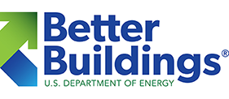

Getting a Home Energy Score™ for Your Home

No matter where you are in your home buying, owning, or renting journey, there is always good reason to better understand your home’s energy use. We all want to live in homes that are comfortable, safe, and affordable to purchase and maintain. Energy features play a vital role in making a home an enjoyable and economical place to live. Homes that are drafty, cold in the winter, hot in the summer, and expensive to run leave residents struggling to choose between staying comfortable and paying their bills.

Developed by the US Department of Energy (DOE) and its national laboratories, the Home Energy Score provides home owners, buyers, and renters credible information about a home’s energy use. Like a miles-per-gallon rating for a car, the Home Energy Score is based on a standard assessment of energy-related assets to easily compare energy use across the housing market.
The Home Energy Score Report estimates home energy use, associated costs, and provides cost-effective energy solutions to improve the home’s efficiency. Each Home Energy Score is shown on a simple one-to-ten scale, where a ten represents the most efficient homes.

Make the Invisible Visible: Show the Value of Home Energy Features
If you are selling your home, a Home Energy Score is a great way to showcase your home’s energy features. Be sure your home’s listing reflects energy investments you have made with a Home Energy Score. The information can also be used by appraisers and mortgage lenders for energy-related financing products. This can make your home more attractive and accessible to potential buyers.
Buyers appreciate having as much information as possible when comparing homes, and the Home Energy Score helps convey this information. One study by Elevate Energy found that listings that include energy costs - even when those costs were high - sold for a higher percentage of the asking price and spent less time on the market than comparable homes that did not disclose energy costs.

Be a Smart Consumer: Know Your New Home’s Energy Use & Costs
Being a smart consumer means knowing everything you can about a potential purchase. Your new home’s energy use impacts your home’s comfort, indoor air quality, and monthly costs. According to the U.S. Census, the average household pays $2,500 in energy costs every year, a higher annual cost than either property tax or insurance.
Ask for a Home Energy Score with your home’s inspection to get everything you need to make an informed purchase. Before renting, ask the landlord to provide a Home Energy Score. If you are buying or refinancing your home, the Home Energy Score can help you qualify for a larger mortgage or more financing options.
If you have already moved in, it is not too late to be a smart consumer: get a Home Energy Score to discover energy solutions that can cost-effectively improve your home’s energy performance and overall Score. Home Energy Score provides guidance on smart home energy upgrades through unbiased energy modeling software.

How Do I Get a Home Energy Score?
Find a Home Energy Score Certified Assessor™ at the US Department of Energy Website

Or, in Eastern Oregon or Washington, Contact:
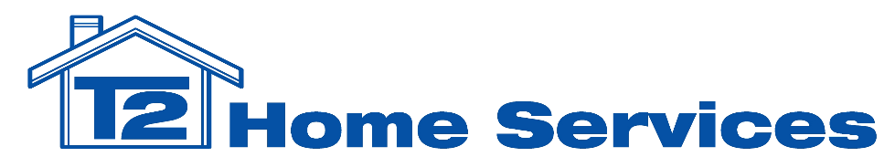

www.t2homeservices.com
541-969-7640
mark@t2homeservices.com

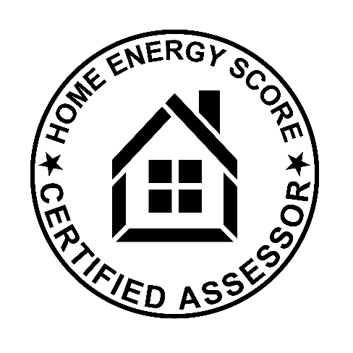
US-ASHI-0259

